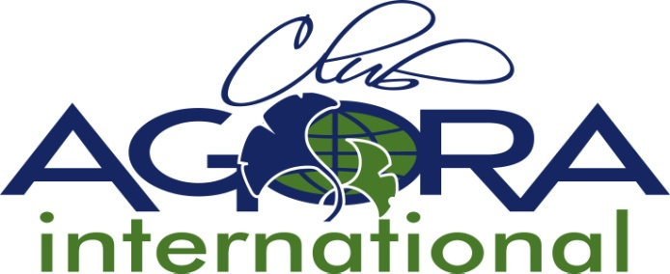

7. APPLICATION FORM ASSOCIATE MEMBERSHIP

Please complete and return to the ACI Secretary before the 30th June
by email secretary@agoraclubinternational.com
The original form should also be sent by Post or Courier to the ACI Secretary.

Name of applying AC Country:

International Godmother Country:

ACI rules regarding Associate Membership applications:

3.2 Associate Membership

3.2.1 As soon as a new group of women decides to join AGORA CLUB INTERNATIONAL they
should contact the International Board. Other member countries could act as godmother club, but the International board must give their approval.
3.2.2 The new club must accept the rules of AGORA Club International. Six months before the charter date the names of the members (at least 5) must be sent to the International Board.
As from the second Agora Club in a country, the minimum number of members will be according the country’s rules, but should never be less than 5 members.
3.2.3 An example of the banner and the logo must be sent to the International Board for approval; the use of the Gingko Biloba leaf is compulsory.
3.2.4 The Aims and Objects of that country shall be sent to the ACI Board (addressed to the ACI Secretary) for approval by the 30th of June prior to the ACI AGM at which it will be considered. The application shall be included on the ACI AGM Agenda circulated to all Member Countries.
3.2.5 The ACI Board shall have approved the Association's Constitution and Rules.
3.2.6 The first Club in any country will automatically receive Associate Membership of ACI, upon the charter of the first Club.
3.2.7 All additional Clubs chartered in an Associate Member country shall automatically be included in that Associate Membership.
3.2.8 Associate Member Countries shall receive all correspondence from ACI.
3.2.9 Associate Member Countries send representatives to the ACI AGM. Such representatives have 1 vote but cannot propose amendments to the ACI Rules.
3.2.10 A member of an Associate Member Country may not stand for office on the ACI board or apply to host an ACI Conference

Number of members at time of application (at least 5 for the number 1 Club):

The National Aims and Objectives, the Logo and Banner and the National Rules are attached to this application form.
(to be approved by ACI board)

Date of Approval by ACI board:
(to be filled by ACI board ):

We apply for Associate Membership of Agora Club International, and shall abide by its rules.

Name and signature President N°1 Club Date

Approved by the Godmother Country’s (National) President :

Name and signature Date

Any other information:

