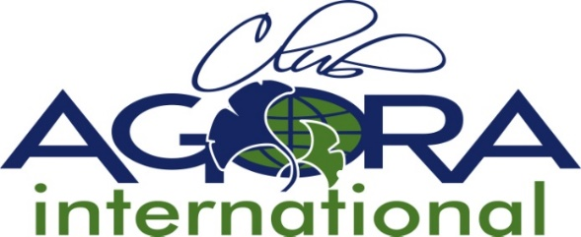

2. Capitation Fee Form
Please complete and return to the ACI Secretary before the 30th June 20…
by mail secretary@agoraclubinternational.com

AC COUNTRY
Number of members in chartered clubs at the time of your national AGM 20…-20… | .....  (members) | 15€ per person | Total (euro)
Total to be paid to ACI before the 1st of December 20…

Agora Club International Bank:
BNP Paribas Fortis
Fortis Bank nv
Lokeren- Belgium
Account number :
IBAN : BE 25 001-6811249-82
BIC/SWIFT : GEBABEBB

Rules concerning the capitation fees:
Capitation fees
7.6 Each member Association shall pay annually a per capita membership fee, for all the members of their Association.
7.7 Full Member Countries and Associate Member Countries shall submit to the ACI Treasurer -immediately after their AGM a statement of membership for the incoming year by the 30th of June. The Capitation Fee due that October shall be determined, based on this figure.
7.8 The capitation fee due per member of each National Association shall be approved annually by the Council at the ACI AGM.
7.9 The capitation fees are due before the 1st of December.
7.10 The Capitation fee is 15€ per member per year.
7.11 The penalty for late payment of the Capitation Fee (after 31st of December) will be 5% of the total capitation fee.

